**DAILY ONLINE ACTIVITIES SUMMARY**

|  |  |  |  |  |  |  |  |
| --- | --- | --- | --- | --- | --- | --- | --- |
| **Date:** | **6-06-2020** | | | | **Name:** | **Harshitha M** | |
| **Sem & Sec** | **8th 'A'** | | | | **USN:** | **4AL16CS038** | |
| **Online Test Summary** | | | | | | | |
| **Subject** | | **IoT** | | | | | |
| **Max. Marks** | | **30** | | **Score** | | **27** | |
| **Certification Course Summary** | | | | | | | |
| **Course** | **Python for machine learning** | | | | | | |
| **Certificate Provider** | | | **Great learning** | **Duration** | | | **1hr** |
| **Coding Challenges** | | | | | | | |
| **Problem Statement:C progam to print right angled traigle numbers** | | | | | | | |
| **Status:Solved** | | | | | | | |
| **Uploaded the report in Github** | | | | **Yes** | | | |
| **If yes Repository name** | | | | **Harshitha-M** | | | |
| **Uploaded the report in slack** | | | | **Yes** | | | |

Online Test Details: (Attach the snapshot and briefly write the report for the same)

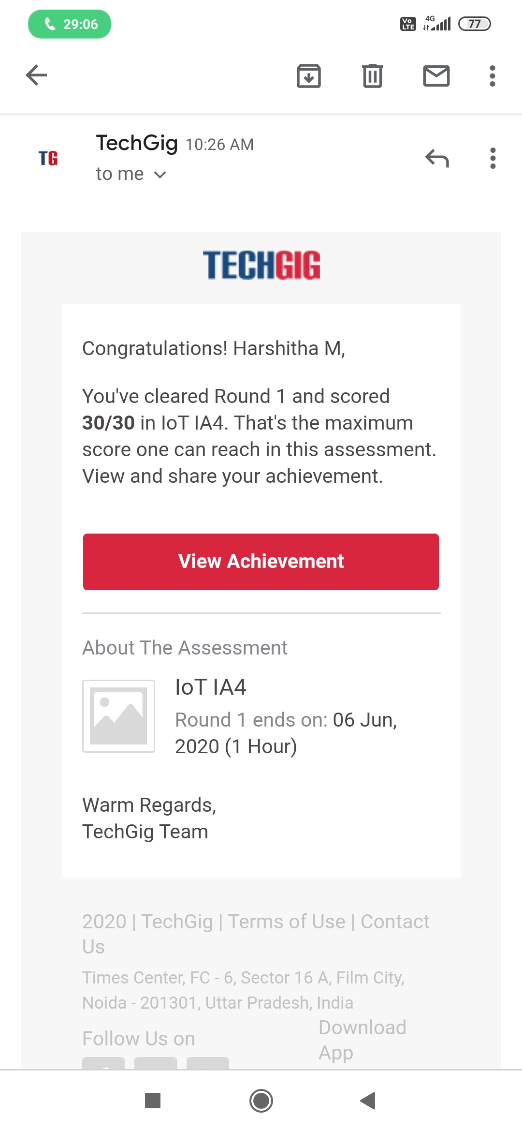

Certification Course Details: (Attach the snapshot and briefly write the report for the same)

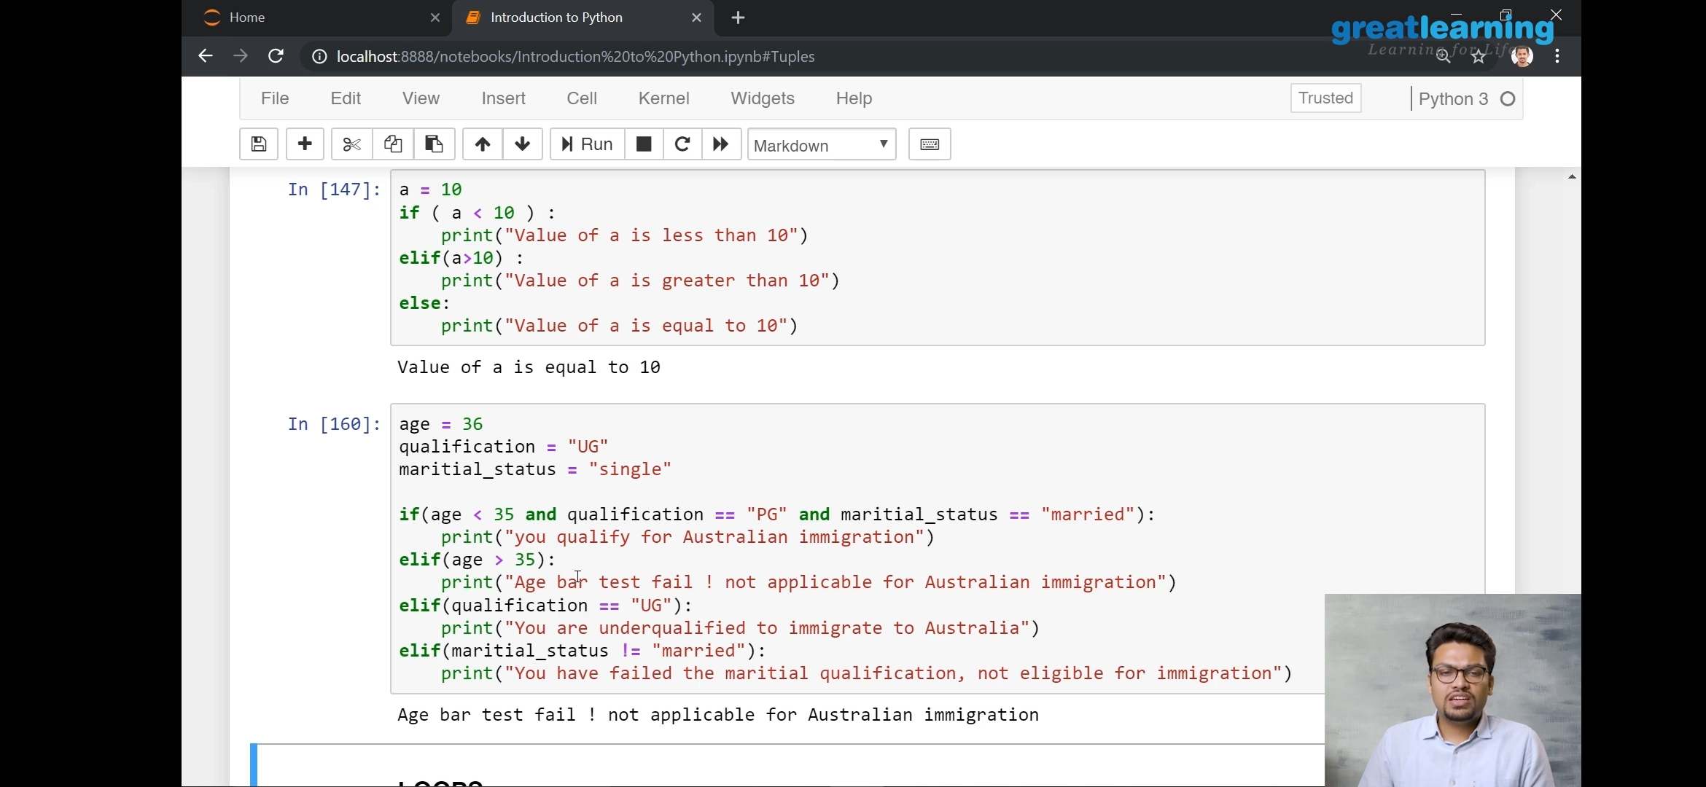

Coding Challenges Details: (Attach the snapshot and briefly write the report for the same)

Program no:1

# Python Program for Find largest prime factor of a number.

import math

def maxPrimeFactors (n):

maxPrime = -1

while n % 2 == 0:

maxPrime = 2

n >>= 1

for i in range(3, int(math.sqrt(n)) + 1, 2):

while n % i == 0:

maxPrime = i

n = n / i

if n > 2:

maxPrime = n

return int(maxPrime)

n = 15

print(maxPrimeFactors(n))

n = 25698751364526

print(maxPrimeFactors(n))